**Steps to create a free API Key for Gemini AI**[**​**](https://www.geminiforwork.gwaddons.com/setup-api-keys/create-geminiai-api-key/#steps-to-create-a-free-api-key-for-gemini-ai)

* **Open Google AI Studio:** Log in to the Google AI Studio for the Gemini AI and click Get API Key.

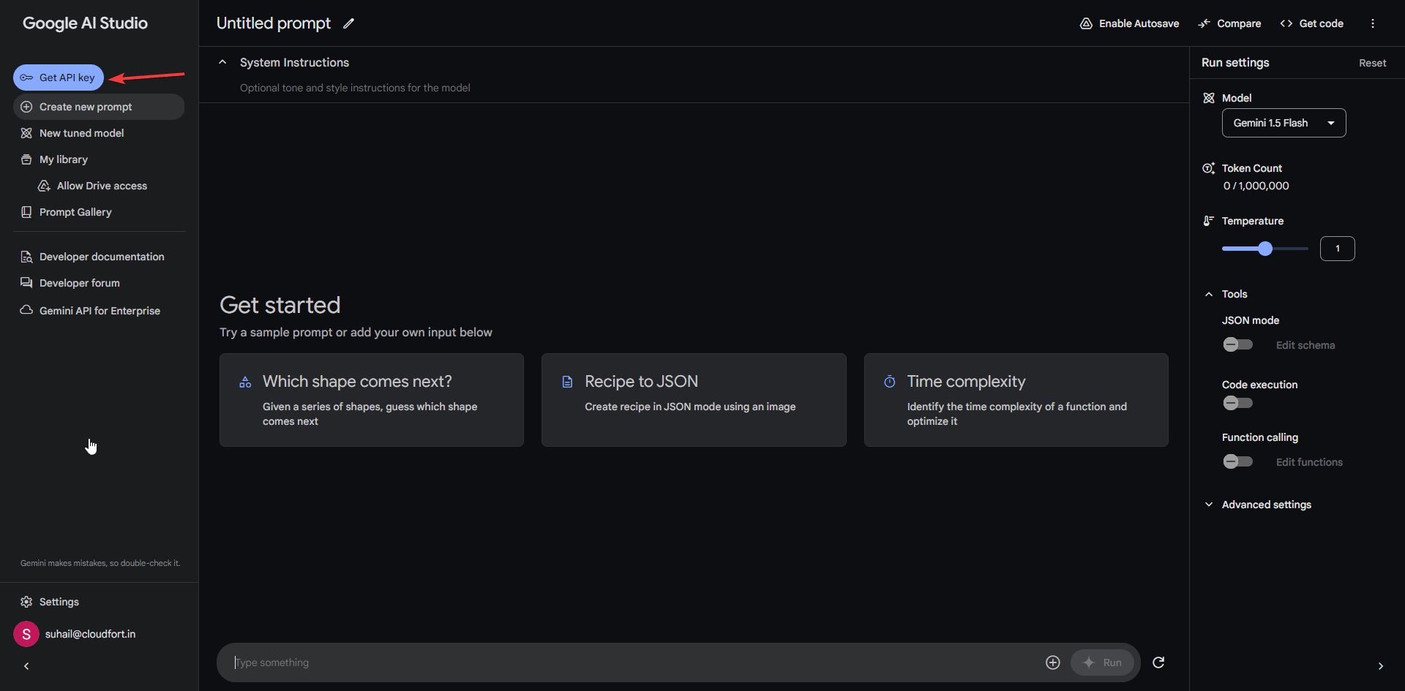

* **Create API Key:** In the API Key section, click on **Create API Key**

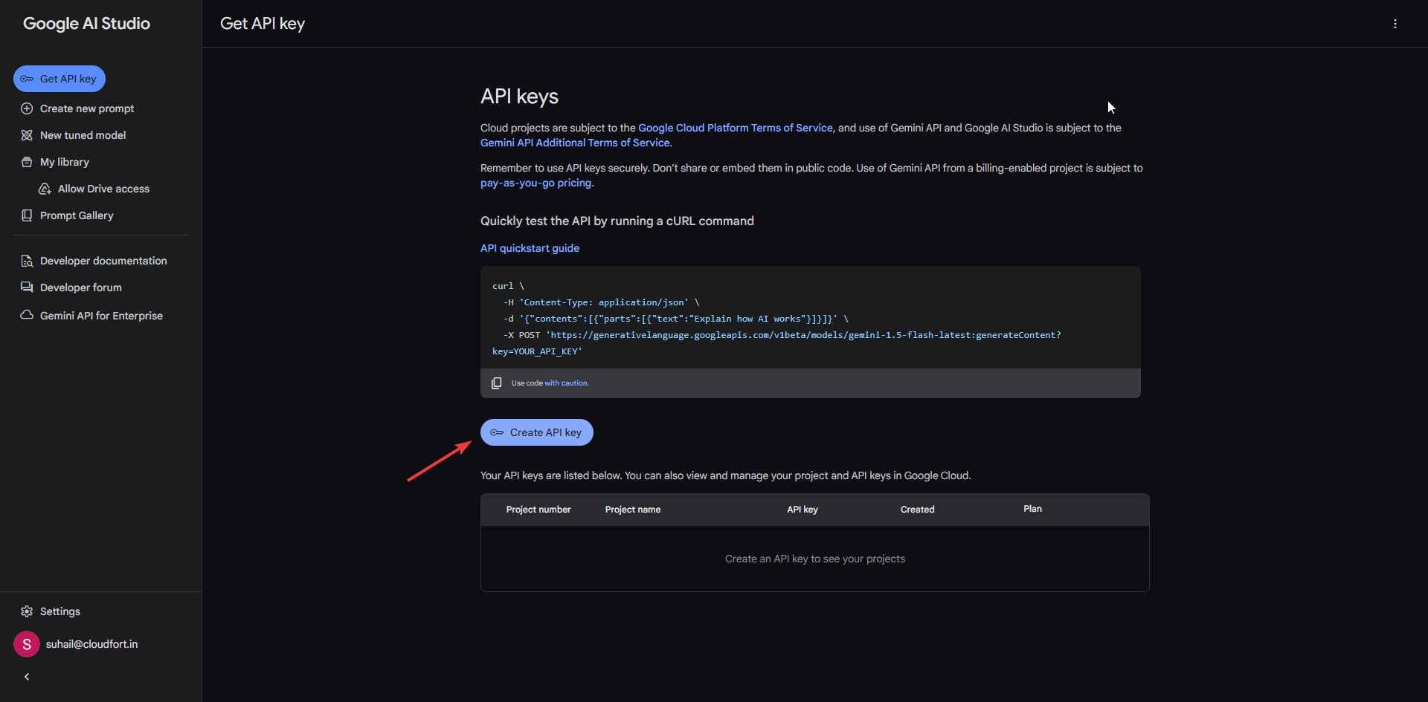

* **Create API Key in New Project:** You can select any existing GCP project or just create API Key in a new project. 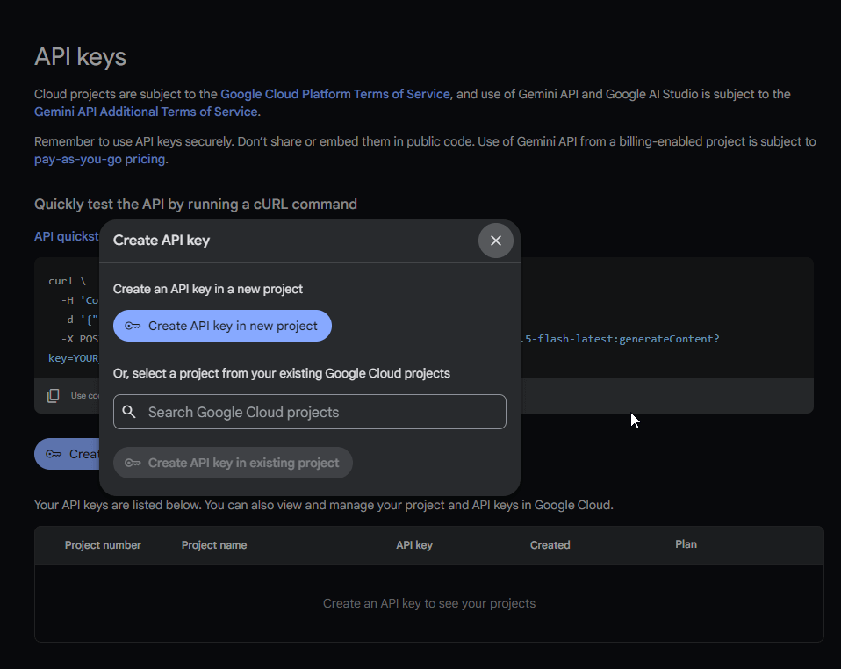
* **Copy the generated API Key:** Once you have created the API key, you will need to copy it. Click on the Copy button next to the API key. 